**BLG 335E – Analysis of Algorithm I, Fall 2017**

**Project 4 Report**

Assignment Date: 7 Dec 2017 Thursday

Due Date: 23 Dec 2017 Friday– 20:00

Kadir Emre Oto

150140032

**Code Analysis**

In this assignment, you were asked to implement a basic Red–Black Tree insert operation and then augment your data structure with extra operations for order statistics.

**Compilation Command**: g++ kod.cpp -o kod -O2 -std=c++11

**Running Command**: ./kod input.txt

**Screenshot of Output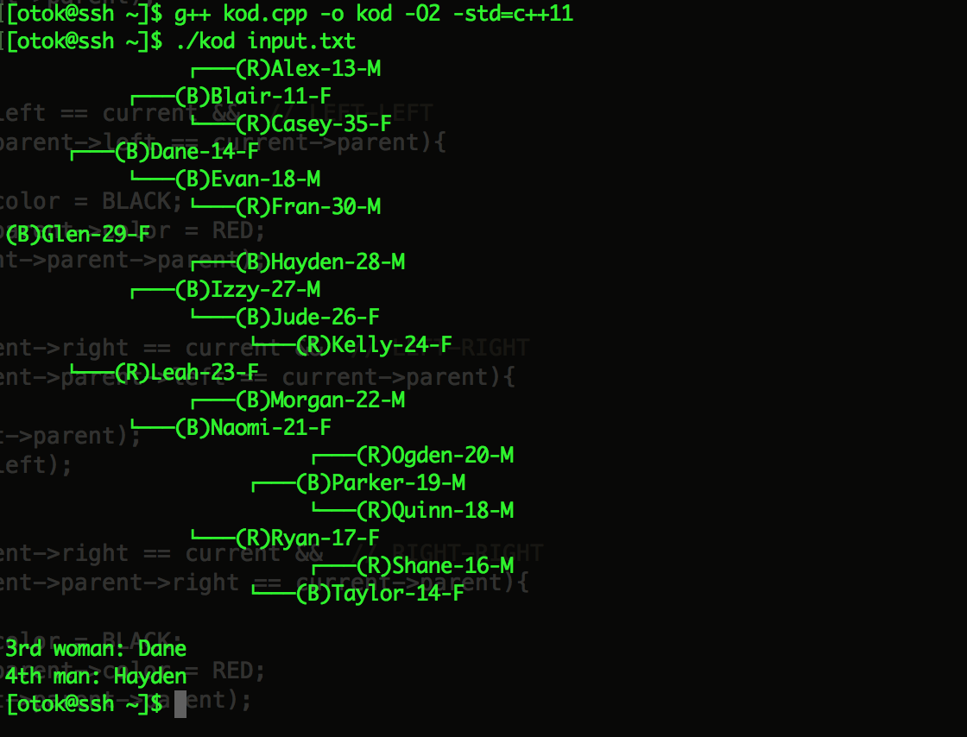 with given input file**

**Question 1:** Briefly explain what you would do to correctly update the name of a person as a node in the Red– Black Tree.

To update the name of a person as a not in RB Tree, I would delete the node first, and change the name of the node and reinsert it.

**Question 2:** Briefly explain what you would do to correctly increment (by 1) the ages of all people in the Red– Black Tree.

With a single Depth First Search (DFS), we can simple increment the ages of all nodes.